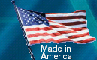

7440 Commercial Circle, Ft. Pierce, FL. 34951-4111

“Case Makers for the Wireless Industry”

Bee® Cases will give you America’s best in Quality, Choice and Value. Made in the
U.S.A., our quality meets of exceeds OEM Standards. We started making cases in 1984.
Below are some helpful images and descriptions to help with your purchasing decisions.

RECOMMENDED USE

Metal clip Swivel Clip Swivel Belt loop Leather clip Neogear®
(Plastic) (Metal)
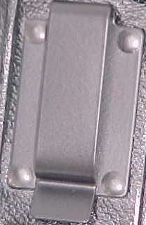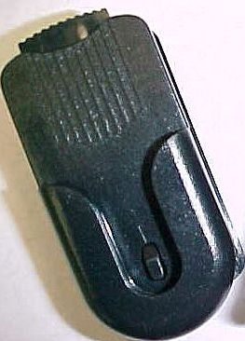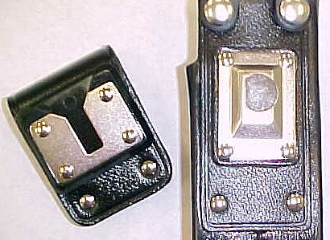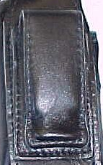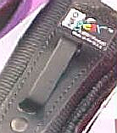

High tension black Popular alternative Full metal quick Available on glove Neogear® black
Powder-coated to the standard disconnect swivel. Leather only. Easy coated spring steal
Spring Steel clip. Metal clip. Lighter Easy to use. A on fine quality belts. Clip. Great for
For rugged duty use. Favorite with police. outdoors
Environment

Heavy Duty Premium Glove Durus® Ballistic Neogear®
Leather Leather Nylon Nylon
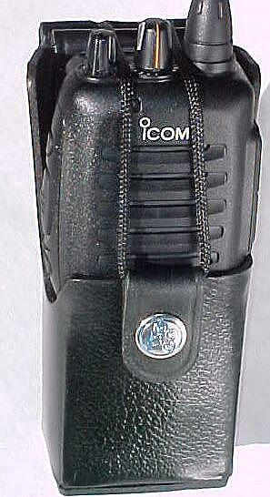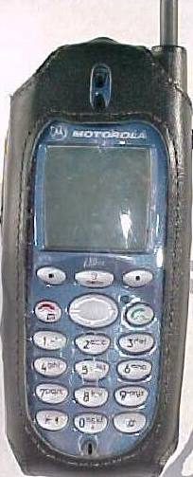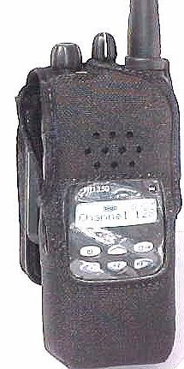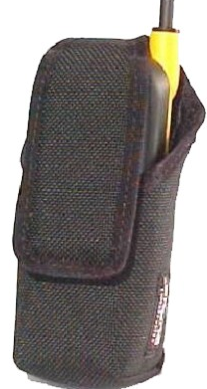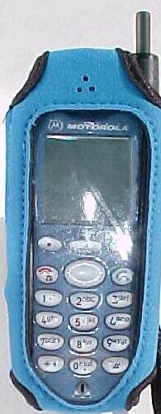

Constructed using Constructed of Constructed of Rugged nylon 11 exciting colors
Top grain U.S. soft supple 1000 Denier Dupont® with water with belt clip or
Cowhide of the leather, tanned nylon. Great when repellent coating popular mini swivel.
Highest quality to perfection. You are looking for a and flame adhered clip. Plastic window
Craftsmanship. High quality heavy-duty case with lining. Protects keypad.
This is our most craftsmanship. Slim profile and light
Rugged case. Full use of phone weight. Excellent
Inside case. Performance in wet
And humid climates.

POC: Jeff Arbuckle
7440 Commercial Circle, Ft. Pierce, FL 34951

Phone: 800-336-3115 Fax: 800-345-2091

E-Mail: (jeffa@beecase.com) Cage#: 1B9R1

